LAB 1: **BASIC MATLAB COMMANDS**

**MATLAB:**

MATLAB stands for matrix laboratory. MATLAB allows matrix manipulations, plotting of functions and data, implementation of algorithms, creation of user interfaces, and interfacing with programs written in other languages including C, C++, Java, etc. The MATLAB application is built around the MATLAB scripting language. Common usage of the MATLAB application involves using the Command Window as an interactive mathematical shell or executing text files containing MATLAB code. This lab deals with an introduction to MATLAB, where students will learn different ways of creating vectors, and to perform various operations on vectors.

**Workspace:**

* The workspace **contains variables that you create or import into MATLAB from data files or other programs**.
* You can view and edit the contents of the workspace in the Workspace browser or in the Command Window. For more information, see Create and Edit Variables.
* 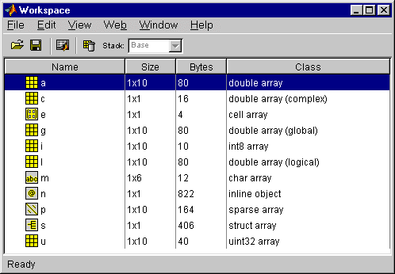Workspace variables do not persist after you exit MATLAB

**Command Window:**

* The Command Window **enables you to enter individual statements at the command line, indicated by the prompt (>>)**.
* As you enter statements, the Command Window displays the results.
* For example, to create the variable a , type a = 1 at the command line and press Enter.

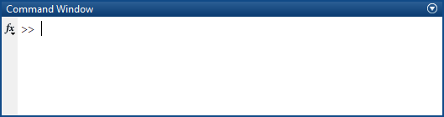

**Editor Window:**

* The MATLAB Editor Window is **a simple text editor where you can load, edit and save complete MATLAB programs**.
* 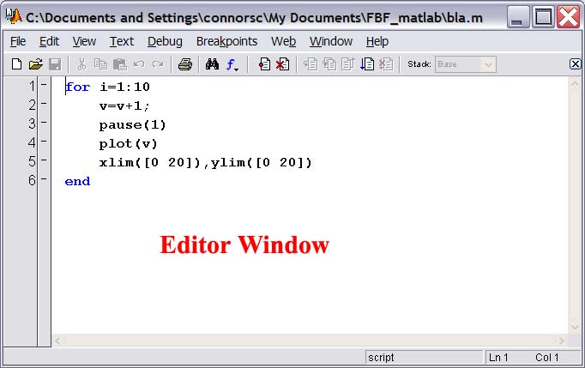The Editor window also has a menu command (Debug/Run) which allows you to submit the program to the command window.

**TASKS:**

**01.**

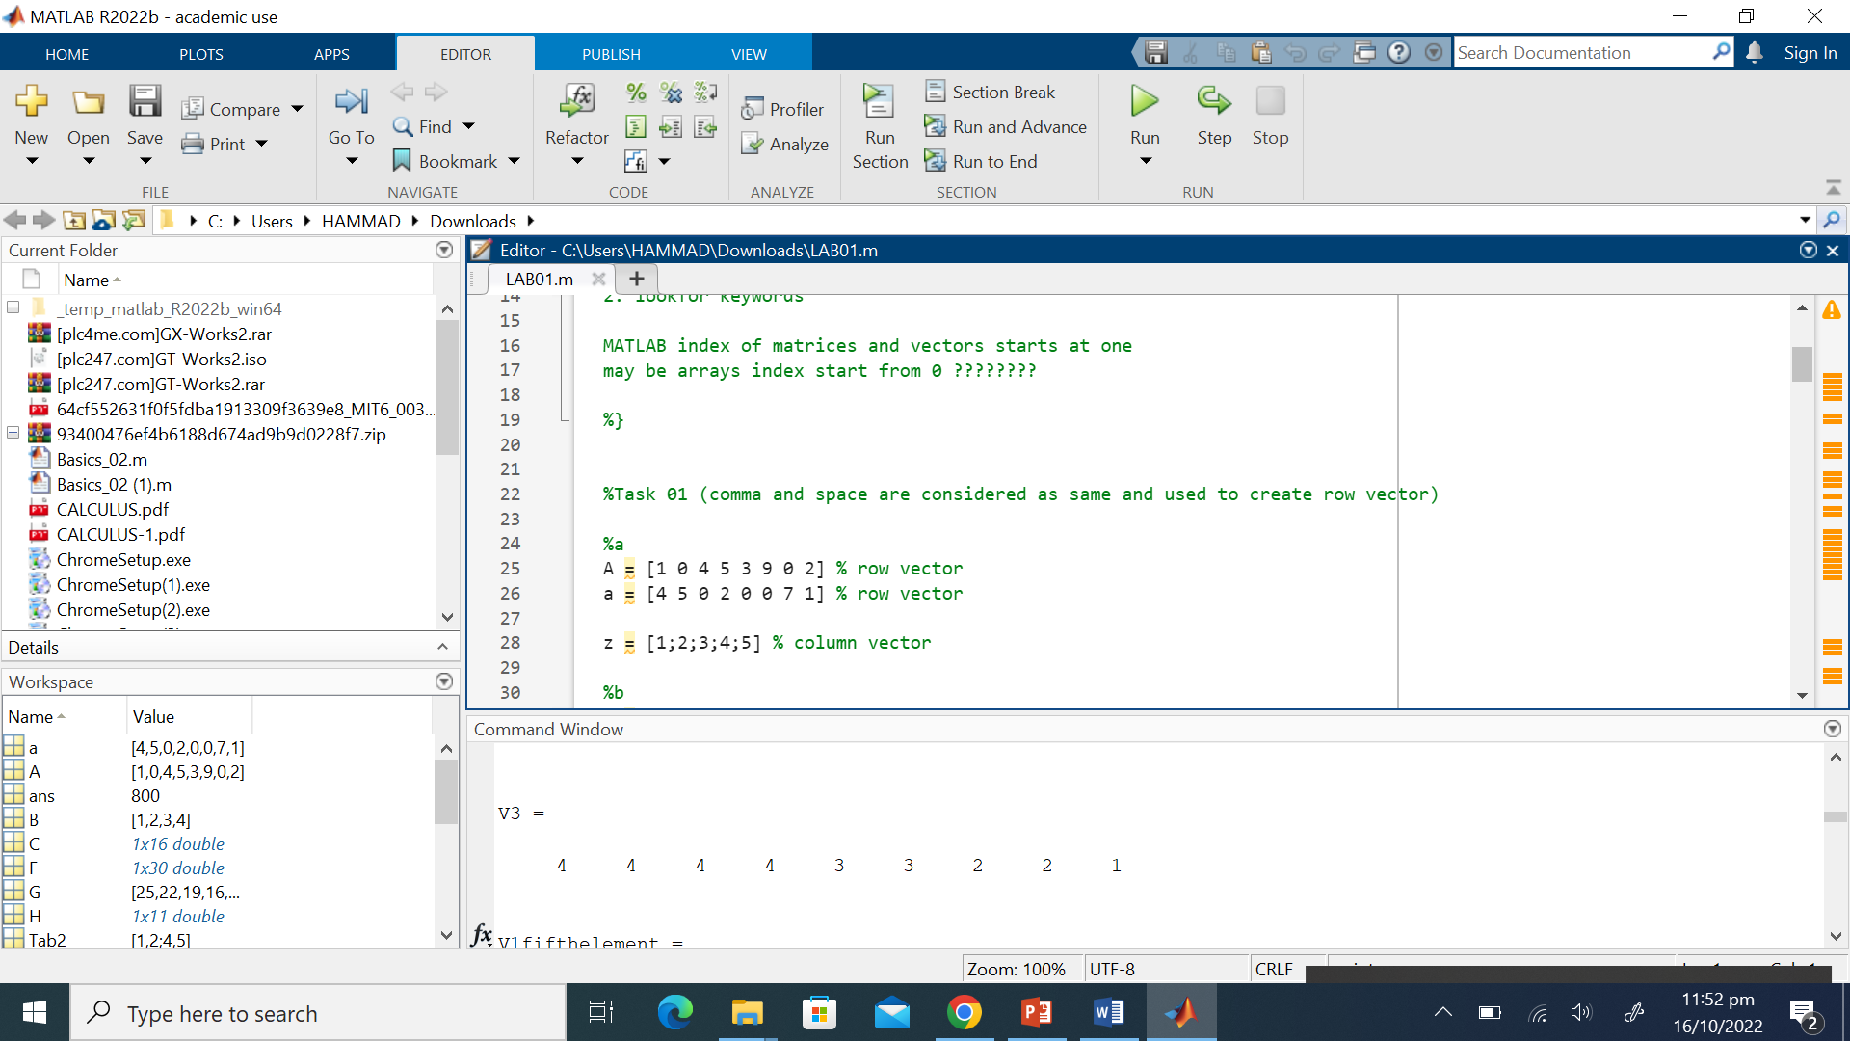

**02.**

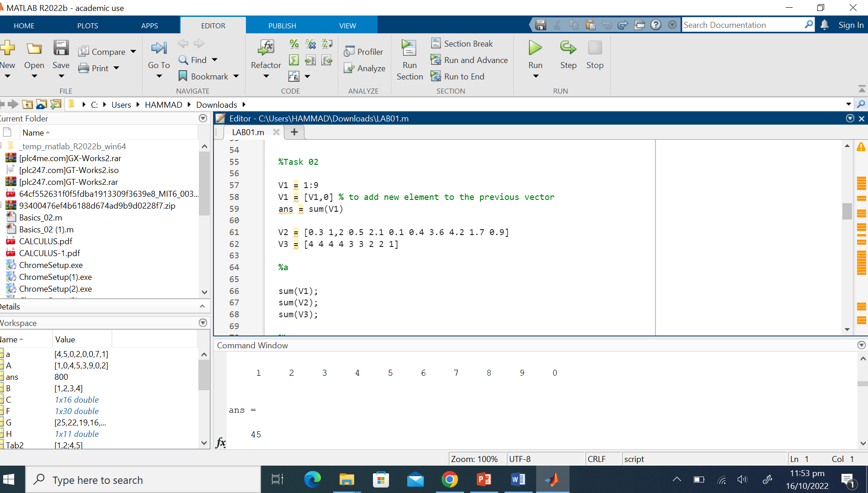

**03.**

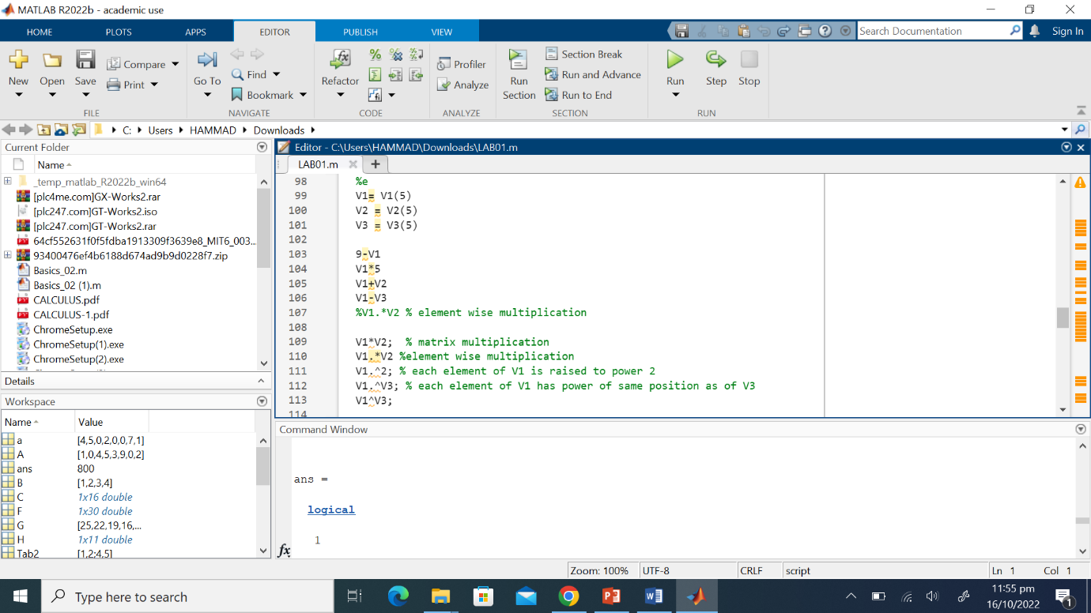

**Conclusion:**

In this lab we have learnt the basics of MATLAB, its Layout and introduction. Furthermore, we have also learnt matrixes and logical operations in MATLAB.

__________________________________________________________________________________